**EXPERIMENT:-** Design automatic LED Diwali lights such that it only works during night and can generate 2 patterns which can be toggled with switch:

1. Pattern 1- LED blinks with a frequency of 500 msec.

b. Pattern 2- LED blinks with a frequency of 1 sec.

**CIRCUIT DIAGRAM:-**

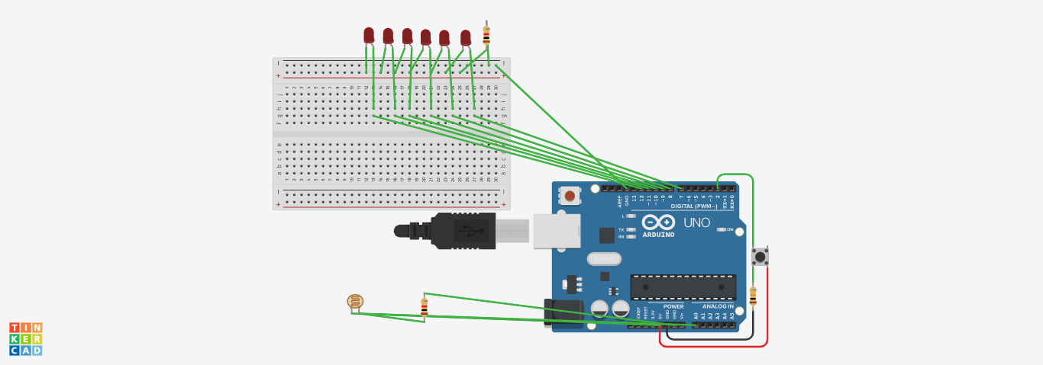

**THEORY:-**

**Concepts used:-**

1. A light dependent resistor (LDR) or a photoresistor is a device whose resistivity is a function of the incident electromagnetic radiation.

2. An electric switch that interrupts the electron flow in a circuit.

3. The Arduino board can supply a power of 5V as digital output signals through 14 pins present in it as digital input or output pins.

**Learning and observations:-**

1. I learnt about different components in an Arduino.

2. The basic importance of Arduino was known.

3. I also learnt the function of LDR in controlling brightness of LED.

**Problems & troubleshooting :-**

1. The connecting wires may not be connected properly.

2. There may be some error in writing program.

3. Wrong attachment of wires in terminals of breadboard.

**Precautions:-**

1. Attach the USB cable and connecting wires carefully.

2. Once the USB cable has been inserted then the Arduino connected to the USB cable should not be touched with bare hands.

**Learning outcomes:-**

1. I learnt how to make connections using breadboard and Arduino.

2. I learnt how to use LDR and control the brightness along with using a switch.